NOTICE TO MARINERS

No.39(T) of 2020
Port of Southampton - Eastern Docks - Scour remediation

Notice is hereby given that works to backfill scour holes in 40-41 and 38-39 berth pockets will commence Mon 30 November 2020. The works are expected to take two weeks.

A shore crane with grab will level the seabed along those berths using gravel.
The crane jib may extend 10m over the quay and shall be used in daylight, weekdays only.
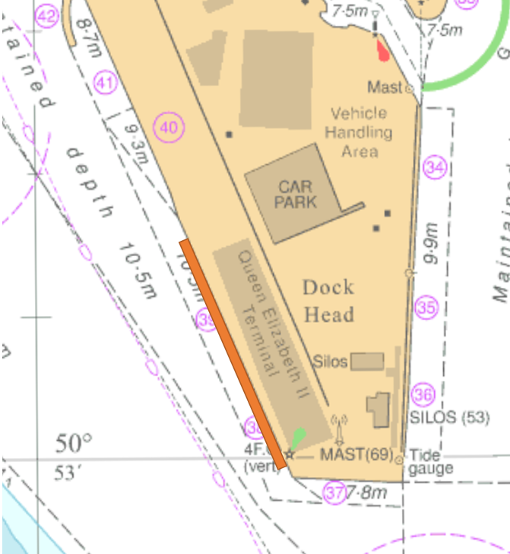

Berths will be tagged-out and fenders moved to facilitate these works as follows.
30-04 December 40-41 berth
07-11 December 38-39 berth

Mariners are to remain clear and be mindful the works may generate dust.

This notice will be self-cancelling on completion

Vessel Traffic Services Centre Ocean Gate, Atlantic Way  Southampton | Steven Masters  Harbour Master

24 November 2020

Owners, Agents, Charterers, Marinas, Yacht Clubs and Recreational Sailing Organisations should ensure that the contents of this Notice are made known to the masters or persons in charge of their vessels or craft.

