Notice to Mariners
No 83 (T) of 2021

Port of Southampton – Eling Wharf Exclusion Zone

NOTICE IS HEREBY GIVEN that an exclusion zone will be in place around Eling wharf quay wall due to degradation and erosion of the quay. Mariners are asked to always keep a minimum of 5m from the quay wall.
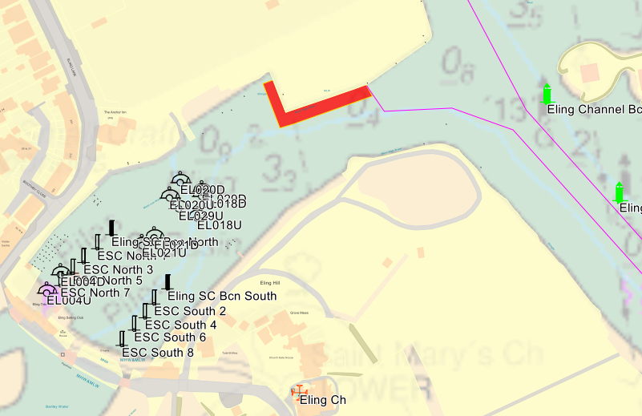

The exclusion zone, extending 5m into the water as shown by the red box in the diagram above. This restriction is expected to remain in place for at least 6 months.

Vessel Traffic Services Centre  Ocean Gate  Atlantic Way  Southampton | Steve Masters  Harbour Master
 | 14th October 2021

Owners, Agents, Charterers, Marinas, Yacht Clubs and Recreational Sailing Organisations should ensure that the contents of this Notice are made known to the masters or persons in charge of their vessels or craft.
www.southamptonvts.co.uk

