REQUEST TO OPERATE A CRANE IN THE PORT OF SOUTHAMPTON

Please return completed application form to MobileCranesSouthampton@abports.co.uk
Name of Customer | Insert text here
Address: | Insert text here
Post Code | Insert text here
Telephone: | Insert text here

Name of Applicant (crane owner): | Insert text here
Address: | Insert text here
Post Code | Insert text here
Telephone: | Insert text here

Date of Application: | Click to select date
Location of Lift: | Insert text here
Date of lift operation and duration | Select date/ type time | Select date/ type time
Weight of lift (tonnes) | Insert text here tonnes
Maximum radius of lift (m): | Insert text here meters
What lifting: | Insert text here
DETAILS OF LIFT - SAFETY CRITICAL INFORMATION
(please include below if the lift is:
‘land to land’; ‘land to vessel or water’; or ‘vessel or water to land’)
Insert text here

Appointed Person

Name of Appointed Person ⁽¹⁾ | Insert text here
Employer | Insert text here
Address | Insert text here
Post Code | Insert text here
Telephone: | Insert text here
¹ Appointed Person to Comply with the requirements of BS7121 Part 3 2017, and hold a Lifting Managers Certificate

Crane Information

Crane hire company Name | Insert text here
Model and Registration | Insert text here
Unladen Weight (a) on road going trim | Insert text here | tonnes
(b) Prepared to lift | Insert text here | tonnes
Capacity (a) At minimum radius of | Insert text here m | Insert text here tonnes
(b) At maximum radius of | Insert text here m | Insert text here tonnes

Health and Safety

PERMISSION WILL NOT BE GRANTED IF ANY OF THE BELOW CANNOT BE ANSWERED YES
1. Do you have a copy of the risk assessment, lift plan and safe system of work covering lift operations and all other activities involving the mobile crane: | ☐Yes ☐No
2. Have ABP SAFETY CODES SC 2 and 10 been reviewed and incorporated into your Safe System of Works? | ☐Yes ☐No
3. Have you read and understood to ABPs Port Safety Rules | ☐Yes ☐No

ABP Marine

IS THE LIFTING OPERATION FROM WATER TO LAND OR VICE VERSA  ( If YES - Confirm compliance with requests below) | ☐Yes ☐No
1. CC: southamptonvts@abports.co.uk and berthingofficers@abports.co.uk in all correspondence | ☐Yes ☐No
2. Any arriving vessels must call “Southampton VTS” VHF Ch12 one hour before berthing alongside. | ☐Yes ☐No
3. Notify Southampton VTS 30mins prior to lifting operation and upon completion on 02380 608 208 | ☐Yes ☐No
4. Adhere to Southampton Byelaws | ☐Yes ☐No
5. Adhere to Southampton Notice to Mariners and Navigation Guidelines | ☐Yes ☐No

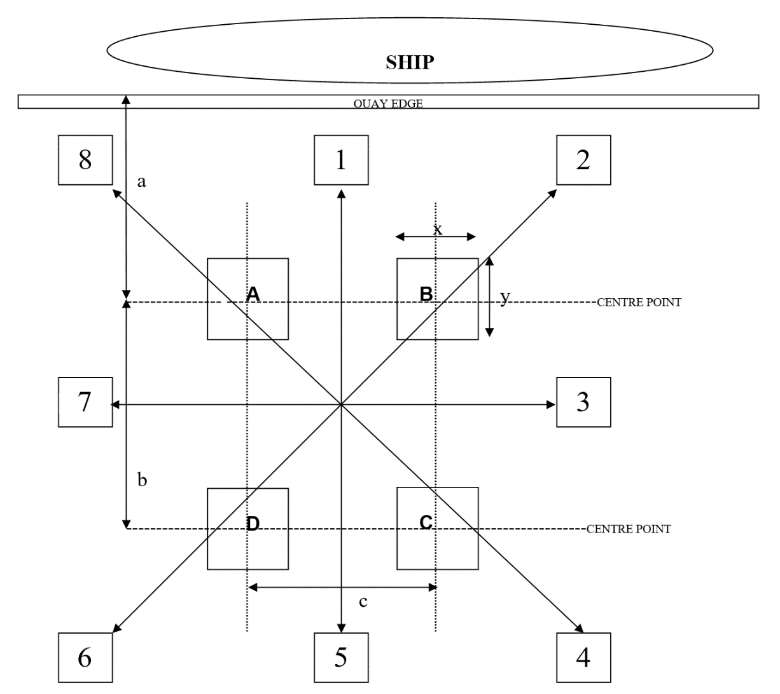

PAD | A | B | C | D
X(M) | Insert text here | Insert text here | Insert text here | Insert text here
Y(m) | Insert text here | Insert text here | Insert text here | Insert text here

DIM | a | b | c
(m) | Insert text here | Insert text here | Insert text here

OUTRIGGER POINT LOADS (tonnes)
JIB POSITION | A | B | C | D
1 | Insert text here | Insert text here | Insert text here | Insert text here
2 | Insert text here | Insert text here | Insert text here | Insert text here
3 | Insert text here | Insert text here | Insert text here | Insert text here
4 | Insert text here | Insert text here | Insert text here | Insert text here
5 | Insert text here | Insert text here | Insert text here | Insert text here
6 | Insert text here | Insert text here | Insert text here | Insert text here
7 | Insert text here | Insert text here | Insert text here | Insert text here
8 | Insert text here | Insert text here | Insert text here | Insert text here

SOUTHAMPTON
USE OF THIRD PARTY MOBILE CRANES

The customer accepts full responsibility for the operation of the lift stated in the attached paperwork, it is therefore the customer’s responsibility to maintain the safety of the operation at all times when operating on the port estate. The customer agrees to be responsible for and to release and indemnify ABP, its employees and agents from, and against, all liability associated with the lift.

The information that ABP may provide is, to the best of our knowledge correct, however we cannot guarantee or take any liability for this information, and it is for guidance purposes only.

Mobile Cranes entering and operating on the port estate will be charged at the rate stated in ABP’s current Principal Rates & Charges & Standard Terms & Conditions of Trade; this will be charged directly to the owners of the crane. Failure to pay any outstanding invoices will result in the crane owners being prevented from entering into and operating on the ABP Port of Southampton estate.

Declaration
Date | Select date/ type time
Signature of applicant | Insert text here
Name in block Capitals | Insert text here
Address | Insert text here
Contact Number | Insert text here

