Solent Incident and Accident Reporting Form

What the form is for - This common reporting form is to be used for maritime incidents that occur in or close to the waters of: ABP Southampton, The Queen’s Harbour Master Portsmouth, Portsmouth International Port, Cowes Harbour Commissioners and Langstone Harbour as shown in the chartlet below.

How to complete the form - The form can be used to report all types of incident or accident, near miss or potential risk. Sections 1-3 and 11 must be completed followed by the relevant section for the type of incident.

If you are reporting a leisure or recreational incident the shorter reporting format at section 12 can be used. In this case there is no need to fill in sections 1-3 or 11.

Once the Form is Completed - Please forward it to the Harbour Master in whose area the incident occurred.

Provenance - This form replaces all existing report forms in use by the port authorities mentioned above.
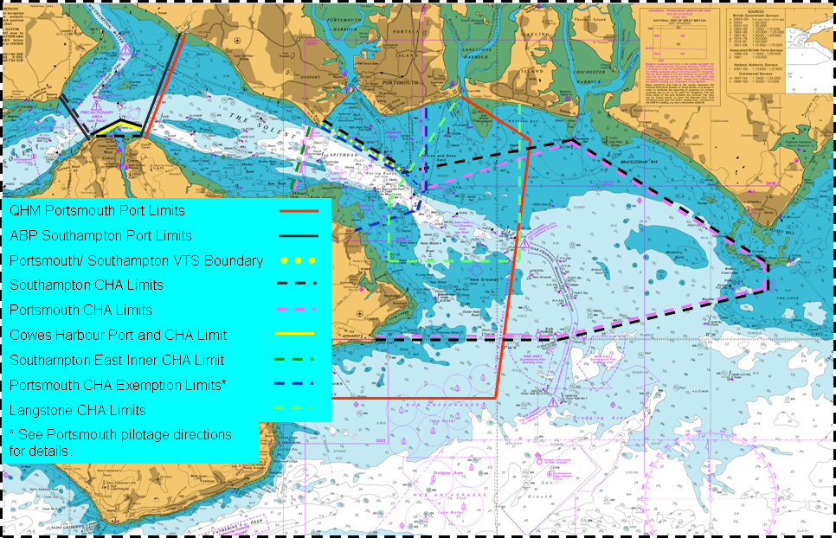
Index
Section Heading

1-3 General Information
4 Close Quarters Situation
5 Grounding
6 Striking/Impact
7 Loss of Anchor and Cable
8 Pollution
9 Accident Report
10 Potential Risk Report
11 Free Text Narrative
12 Leisure/Recreational
Incident Short Report

Section 1 – Type of Incident – Please circle
Collision |  | Grounding |  | Striking |  |  | Loss of Anchor |  | Pollution
Accident/Near Miss/Potential Risk |  |  |  |  | Other (Specify):
Use most relevant section and then the free text at section 11.

Section 2 - Personal Details:
Name/ Pilot / PEC number
Address
Phone Number
Email Address
Witness details (if applicable)
Section 3 - General Details:
Ships Name
Date of incident (dd/mm/yyyy)
Time of incident (24 hr clock)
Position of incident (or) | Lat: |  | Long:
Position of incident | Range: | Brg: | From:
Direction and rate of tidal stream
Wind speed/direction (Beaufort)
Sea State (Beaufort)
Visibility (In miles)
GRT/NRT
Length/Beam/Draught (Metres)
Owners name/Address
Agent name and telephone No
Destination port
Source of position information
Datum selected in GPS
Chart Positions Retained | Yes No
Actions taken after incident (own)
Actions taken after incident (other)
Written statement from master | Yes No

Please sign and date this section and complete the appropriate section as applicable and section 11:
Name: | Date: |  |  | Signature:
Office Use only:
Name: | Date: |  |  | Signature:

Section 4 – Close Quarters Situation:
Name of other vessel/object
Ship’s heading at time of incident
Type of lookout maintained
Speed/Engine Setting
Bridge control |  | Yes No
Bow/Stern thrusters in use |  | Yes No
Steering mode (Auto/manual/NFU)
Compass in use (Mag/Gyro etc…)
Time/range other vessel was first seen
Estimated course/speed of other vessel
True course steered at incident
Length of time on this course
Lights/signals displayed (both vessels)
Sound signals (both vessels)
Use of VHF (channel and content)
Use of engines
Course alterations (own ship)
Course alterations (other ship)
Other authorities contacted |  | Time:  Time:
List relevant machinery/equipment defects
Describe any unusual handling characteristics
Please sign and date this Section and continue to section 11:
Name: | Date: |  |  | Signature:

Section 5 - Grounding:
Main propulsion
Propeller(s) |  | Type: | How many: |  |  |  | Rotation:
Rudders |  | Type/Number:
Ship’s heading at time of incident
Echo sounder in use |  | Yes No |  | Trace Retained: Yes No
Speed/Engine(s) setting
Bridge control |  | Yes No
Bow/Stern thrusters in use |  | Yes No
Steering mode (Auto/manual)
Compass in use (Mag/Gyro etc…)
True course steered at incident
Length of time on this course
Previous true course steered
Length of time on this course
Use of engines
Engine movements before grounding
Cargo carried
Dangerous substance carried
Bunkers remaining
Leakage of fuel/oil
How was vessel refloated
How long was vessel aground
Relevant machinery/equipment defects
Any unusual handling characteristics?
Tugs in use |  | Names:
 |  | Positions & Orientation:
Other authorities contacted |  | Time:
Please sign and date this Section and continue to section 11:
Name: | Date: |  |  |  | Signature:
Section 6 – Striking/Impact/Collision:
Object struck
Ship’s heading at time of incident
Length of time on this course
Previous true course steered
Own speed at time of incident
Estimated course/speed of other vessel
Previous course/speed of other vessel
Own main engine propulsion
Propeller(s) |  | Type: |  | How many: |  | Rotation:
Rudders |  | Type/Number:
Own engine(s) setting
Engine movements prior to collision
Bridge control |  | Yes No
Bow/Stern thrusters in use |  | Yes No
Steering mode (Auto/manual)
Compass in use (Mag/Gyro etc…)
Tugs in use |  | Names
 |  | Positions & Orientation
Other authorities contacted |  | Time
 |  | Time
Visual signals made (own ship)
Sound signals (own ship)
Was tug being watched
Use of VHF (channel and content) |  | (Provide recording or transcripts)
Cargo/Dangerous substance carried
Pollution |  | (Please also complete Section 8)
List relevant machinery/equipment defects/ handling characteristics
Please sign and date this Section and continue to section 11:
Name: | Date: |  |  |  | Signature:
Section 7 – Loss of Anchor and Cable:
Position of lost anchor/cable
Ship’s heading at time of incident
At anchor or underway
Speed at time of incident
Main engine propulsion
Propeller(s) |  | Type: | How many: |  |  |  | Rotation:
Rudders |  | Type: |  |  |  | How many:
Bow/stern thrusters fitted
Engine(s) setting
Bridge control
State which anchor involved
Amount/Size of cable lost
Slipped or parted (state)
If slipped why
If anchoring, how much cable was on deck prior to letting go
Other authorities contacted |  | Time:
 |  | Time:
List relevant machinery/equipment defects
Please sign and date this Section and continue to section 11:
Name: | Date: |  |  |  | Signature:

Section 8 – Pollution:
Type of pollution
Cause of pollution
Estimate of amount of pollutant spilled
Geographic extent of pollution
Fuel Grade
Immediate actions taken
Other authorities contacted |  | Time:
 |  | Time:
Type of response equipment used
Extent of any damage to vessel
Please sign and date this Section and continue to section 11:
Name: | Date: |  |  | Signature:

Section 9 - Accident Report Form
Person Reporting the Accident:
Title/Rank: |  | Name:
Address:
Occupation:
The Person having the accident:
Title/Rank |  | Name:
Address:
Occupation:
About the accident:
Where did it happen? What time did it happen? How did it happen?

Details of any injuries:
Please sign and date the form:
Name: | Date: |  |  |  | Signature:

Section 10 - Potential Risk Report
Mr/Mrs/Rank: |  | Name:
Address:
Email address:
Telephone Number:
Details of risk:
Date/Time:
Location:
Weather/Tide:
Description of risk:
Please sign and date the form:
Name: | Date: |  |  |  |  | Signature:
Office Use only:
Name: | Date: |  |  |  | Signature:
Section 11 Free Text Report:
Describe in your own words how the incident developed. Please use any charts, drawings, sketches photographs of other evidence that may assist in recreating the event and use additional blank sheets if required. The description should include:
-A factual narrative of events including cause (and timings if possible).
-Any material damage sustained.
-Any pollution.
-Any actions you have taken or recommendations you or others might have.
-Details of any injuries sustained.
If there is insufficient space above to complete your description, please use additional sheets and fasten them securely to this form. Please indicate here the number of continuation sheets you have used:
Please sign and date this Section:
Name: | Date: |  |  | Signature:

Office Use Only:
Name: | Date: | Signature:

